

II Międzynarodowy Arcymistrzowski Turniej Szachowy
im. Unii Lubelskiej – Lublin 8-18.05.2010

Biuletyn

Runda: 8

Nr | Tyt. | Imię i nazwisko | Fed. | Rank. | 1 | 2 | 3 | 4 | 5 | 6 | 7 | 8 | 9 | 10 | S | Mce
1 | GM | Marcin Dziuba | POL | 2576 | X | = | 1 | = | = | = | = | = |  | = | 4,5
2 | GM | Sergiej Tiviakov | NED | 2634 | = | X | 0 | 0 | = | 1 | = |  | 0 | 1 | 3,5
3 | GM | Vladimir Baklan | UKR | 2633 | 0 | 1 | X | = | 0 | 1 |  | = | = | = | 4
4 | GM | Boris Grachev | RUS | 2667 | = | 1 | = | X | = |  | = | = | = | 1 | 5
5 | GM | Bartosz Soćko | POL | 2644 | = | = | 1 | = | X | 1 | = | = | = |  | 5
6 | GM | Dariusz Świercz | POL | 2501 | = | 0 | 0 |  | 0 | X | 0 | 0 | = | = | 1,5
7 | GM | Mateusz Bartel | POL | 2609 | = | = |  | = | = | 1 | X | = | = | 1 | 5
8 | GM | Georg Meier | GER | 2638 | = |  | = | = | = | 1 | = | X | = | = | 4,5
9 | GM | Bartłomiej Macieja | POL | 2618 |  | 1 | = | = | = | = | = | = | X | = | 4,5
10 | GM | Igor Kurnosov | RUS | 2680 | = | 0 | = | 0 |  | = | 0 | = | = | X | 2,5
www.lzszach.lublin.pl/arc2010
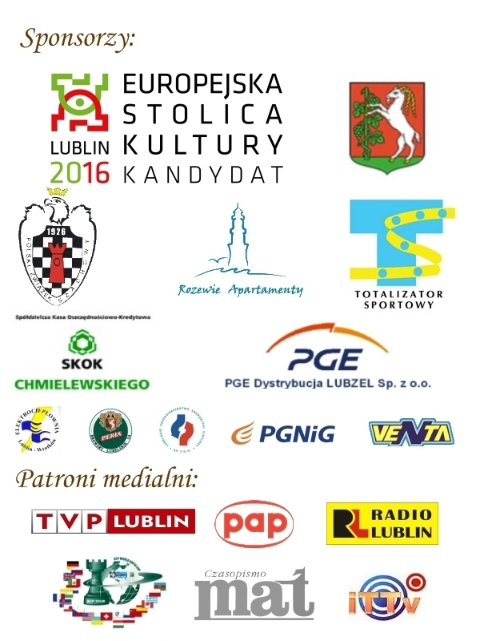

Partie rundy 8:

(1) Baklan,Vladimir (2633) - Swiercz,Dariusz (2501)
1.e4 e6 2.d4 d5 3.exd5 exd5 4.Sf3 Sf6 5.Gg5 Ge7 6.Gd3 Gg4 7.0–0 0–0 8.Sbd2 Sbd7 9.c3 c6 10.We1 Gh5 11.Hb3 Sb6 12.a4 Hc7 13.a5 Sc8 14.Se5 Gg6 15.Sxg6 hxg6 16.Sf3 Sh5 17.Gd2 Sd6 18.Se5 Wfe8 19.We2 Gf8 20.Ha4 We6 21.Wae1 Wae8 22.g3 Sf6 23.f3 Sd7 24.b3 a6 25.Kg2 Sb5 26.Sg4 Wxe2+ 27.Wxe2 Wxe2+ 28.Gxe2 Sf6 29.Sf2 Ge7 30.Ha1 Hd8 31.Sd3 Gd6 32.Gf1 Sd7 33.He1 Gc7 34.b4 Gd6 35.Kf2 Kf8 36.Gh3 He7 37.Hxe7+ Kxe7 38.Ke2 Kd8 39.Kd1 Sf8 40.Kc2 Sd7 41.Kb3 Sc7 42.Gg5+ f6 43.Ge3 Ke7 44.c4 dxc4+ 45.Kxc4 Sd5 46.Gd2 Sf8 47.Gg2 Se6 48.Sb2 Sxd4 49.Kxd4 Ge5+ 50.Kc5 Gxb2 51.f4 Kd7 52.Gxd5 cxd5 53.Kxd5 f5 54.Ge3 Gf6 55.Gd4 Ge7 56.Kc4 g5 57.fxg5 g6 58.Ge3 Ke6 59.Gd2 Gd6 60.Gf4 Ge7 61.b5 Gf8 62.b6 Gg7 63.Gd2 Ge5 64.Kd3 Kd5 65.Ke3 Ke6 66.Kf3 Gd6 67.h4 Ge5 68.g4 Gb2 69.h5 fxg4+ 70.Kxg4 Kf7 71.h6 Ke6 72.Kf4 Kd5 73.Ke3 Ke6 74.Kd3 Kf7 75.Gc3 Gc1 76.h7 1–0

(2) Dziuba,Marcin (2576) - Meier,Georg (2638)
1.d4 Sf6 2.c4 e6 3.g3 d5 4.Sf3 dxc4 5.Gg2 Sc6 6.0–0 a6 7.Gg5 Wb8 8.e3 b5 9.Sfd2 Sa5 10.b3 Gb7 11.Gxb7 Wxb7 12.bxc4 c5 13.cxb5 axb5 14.Sb3 cxd4 15.Sxd4 Ge7 16.Sc3 b4 17.Ha4+ Wd7 18.Gxf6 Gxf6 19.Scb5 Ge7 20.a3 bxa3 21.Sxa3 0–0 22.Wfd1 Gxa3 23.Wxa3 Sb7 24.Wc1 Wc7 25.Wac3 Wxc3 26.Wxc3 Sd6 27.Sc6 Hc7 28.Ha7 Hxa7 29.Sxa7 Se4 30.Wc7 f6 31.f3 1/2

(3) Grachev,Boris (2667) - Socko,Bartosz (2644)
1.d4 d5 2.c4 dxc4 3.e3 Sf6 4.Gxc4 e6 5.Sf3 c5 6.0–0 a6 7.dxc5 Gxc5 8.Hxd8+ Kxd8 9.Se5 Ke7 10.Ge2 Gd7 11.Gf3 Sc6 12.Gxc6 Gxc6 13.Sxc6+ bxc6 14.Gd2 Se4 15.Wc1 Wab8 16.b3 Gd6 17.Ge1 Ge5 18.Sc3 Sxc3 19.Gxc3 Gxc3 20.Wxc3 Wb6 21.Kf1 Wd8 22.Ke2 e5 23.Wac1 Wd6 24.Wc5 f6 25.W1c4 Kd7 26.Wa5 Kc7 27.f4 exf4 28.exf4 Kb7 29.Wca4 We6+ 30.Kf3 We1 31.Wh5 h6 32.We4 Wxe4 33.Kxe4 Wb4+ 34.Kf5 a5 35.g3 a4 36.bxa4 c5 37.g4 Wxa4 38.g5 fxg5 39.fxg5 Kc6 40.gxh6 gxh6 41.Wxh6+ Kd5 42.Wh8 Wxa2 43.Wd8+ Kc4 44.h4 Wf2+ 1/2

(4) Tiviakov,Sergei (2634) - Bartel,Mateusz (2609)
1.e4 c6 2.d4 d5 3.Sd2 dxe4 4.Sxe4 Gf5 5.Sg3 Gg6 6.Sh3 Sf6 7.Gc4 e6 8.Sf4 Gd6 9.c3 Hc7 10.Hf3 Sbd7 11.Gb3 0–0–0 12.0–0 Whe8 13.Sxg6 hxg6 14.We1 c5 15.Gg5 Ha5 16.Se4 Ge7 17.Gf4 Sxe4 18.Wxe4 Sf6 19.We2 Hb6 20.Ge5 Hc6 21.Hxc6+ bxc6 22.Gc4 Kb7 23.a4 cxd4 24.Gxd4 c5 25.Ge3 Sd5 26.Gd2 a6 27.a5 Wd7 28.g3 Wed8 29.Ge1 Sc7 30.Gb3 Sb5 31.f4 Wc7 32.Wa4 Kb8 33.Kg2 Wb7 34.Gc2 Sd6 35.Gd3 Sb5 36.Ge4 Wc7 37.Gf2 Wdd7 38.g4 Gd6 39.Gc2 We7 40.Wae4 Wb7 41.Wc4 Sc7 42.Ga4 Sd5 43.Kf3 Wec7 44.h4 Wc8 45.f5 gxf5 46.gxf5 We7 47.Wd2 g6 48.fxe6 fxe6 49.We4 Wf8+ 50.Kg2 Kc7 51.Wc4 Wf4 52.Wxf4 Sxf4+ 53.Kf3 Wf7 54.Ke4 Sd5 55.Gb3 Kc6 56.Ga4+ Kc7 57.Gb3 Kc6 58.Ga4+ Kc7 1/2

(5) Kurnosov,Igor (2680) - Macieja,Bartlomiej (2618)
1.e4 c5 2.Sf3 Sc6 3.d4 cxd4 4.Sxd4 g6 5.Sc3 Gg7 6.Ge3 Sf6 7.Gc4 0–0 8.Gb3 d6 9.f3 Gd7 10.Hd2 Sxd4 11.Gxd4 b5 12.a4 b4 13.Sd5 Sxd5 14.exd5 Gxd4 15.Hxd4 Hb6 16.Hxb6 axb6 17.Kd2 e5 18.dxe6 fxe6 19.Ke3 d5 20.Whd1 Wa5 21.Wd4 b5 22.Wxb4 Wfa8 23.Wd1 bxa4 24.Ga2 a3 25.bxa3 Wb5 26.Gb3 Wxa3 27.Wxb5 Gxb5 28.Kd4 Ga4 29.Gxa4 Wxa4+ 30.Ke5 Wc4 31.Kxe6 Wxc2 32.Wxd5 Wxg2 33.Kf6 h5 34.Wg5 Wxg5 35.Kxg5 Kg7 36.f4 Kf7 37.h4 Kg7 38.f5 1/2

