

II Międzynarodowy Arcymistrzowski Turniej Szachowy
im. Unii Lubelskiej – Lublin 8-18.05.2010

Biuletyn

Runda: 7

Nr | Tyt. | Imię i nazwisko | Fed. | Rank. | 1 | 2 | 3 | 4 | 5 | 6 | 7 | 8 | 9 | 10 | S | Mce
1 | GM | Marcin Dziuba | POL | 2576 | X | = | 1 | = | = | = | = |  |  | = | 4
2 | GM | Sergiej Tiviakov | NED | 2634 | = | X | 0 | 0 | = | 1 |  |  | 0 | 1 | 3
3 | GM | Vladimir Baklan | UKR | 2633 | 0 | 1 | X | = | 0 |  |  | = | = | = | 3
4 | GM | Boris Grachev | RUS | 2667 | = | 1 | = | X |  |  | = | = | = | 1 | 4,5
5 | GM | Bartosz Soćko | POL | 2644 | = | = | 1 |  | X | 1 | = | = | = |  | 4,5
6 | GM | Dariusz Świercz | POL | 2501 | = | 0 |  |  | 0 | X | 0 | 0 | = | = | 1,5
7 | GM | Mateusz Bartel | POL | 2609 | = |  |  | = | = | 1 | X | = | = | 1 | 4,5
8 | GM | Georg Meier | GER | 2638 |  |  | = | = | = | 1 | = | X | = | = | 4
9 | GM | Bartłomiej Macieja | POL | 2618 |  | 1 | = | = | = | = | = | = | X |  | 4
10 | GM | Igor Kurnosov | RUS | 2680 | = | 0 | = | 0 |  | = | 0 | = |  | X | 2
www.lzszach.lublin.pl/arc2010
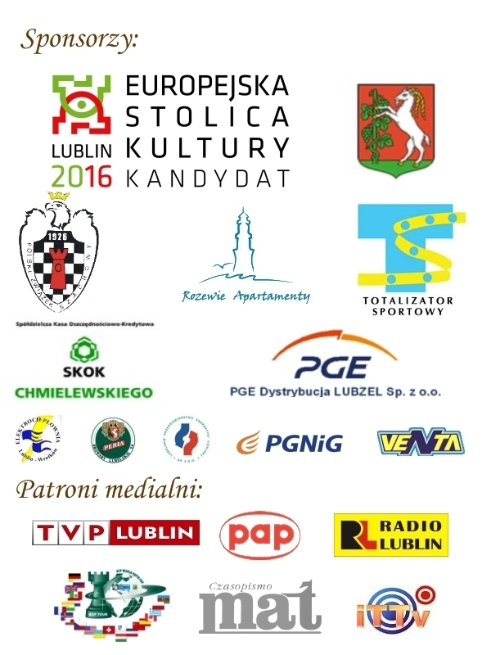

Partie rundy 7:

(1) Meier,Georg (2638) - Macieja,Bartlomiej (2618)
1.d4 d5 2.c4 c6 3.Sf3 Sf6 4.e3 Gg4 5.Sc3 e6 6.h3 Gxf3 7.Hxf3 Sbd7 8.Gd2 Gb4 9.Gd3 0–0 10.a3 Gd6 11.cxd5 exd5 12.g4 Sb6 13.g5 Sfd7 14.Hf5 g6 15.Hg4 He7 16.h4 c5 17.0–0–0 cxd4 18.exd4 Gxa3 19.Wde1 Hb4 20.bxa3 Hxa3+ 21.Kc2 Sa4 22.Sxa4 Hxa4+ 23.Kb2 Sc5 24.Gc2 Hb5+ 25.Ka1 Ha6+ 26.Kb2 Hb5+ 27.Ka1 Ha6+ 28.Kb2 Hb5+ 1/2

(2) Socko,Bartosz (2644) - Baklan,Vladimir (2633)
1.d4 Sf6 2.Sf3 e6 3.c4 b6 4.g3 Gb7 5.Gg2 Ge7 6.Sc3 Se4 7.Hc2 Sxc3 8.Hxc3 Ge4 9.0–0 0–0 10.Gh3 c5 11.dxc5 bxc5 12.He3 d5 13.Sd2 Gg6 14.f4 d4 15.Hf3 Sd7 16.e4 dxe3 17.Hxe3 Gf6 18.Kh1 Sb6 19.Gg2 Wb8 20.Se4 Gd4 21.He2 Sa4 22.Wb1 We8 23.Hc2 Hd7 24.Wd1 Hb7 25.h4 Ha6 26.Wd3 Sb6 27.b3 Sd5 28.He2 Gxe4 29.Gxe4 f5 30.cxd5 fxe4 31.We3 Hxe2 32.Wxe2 exd5 33.Ga3 Wb5 34.Wd1 h5 35.Wc2 Kf7 36.Kg2 Ke6 37.Kh3 g6 38.g4 hxg4+ 39.Kxg4 Wa5 40.Gc1 Wb5 41.Ga3 a5 42.Wdc1 Ge3 43.We1 d4 44.Gc1 Kd5 45.Gxe3 dxe3 46.Wxe3 Wb4 47.Wec3 Wc8 48.Kg5 Wc6 49.f5 gxf5 50.Kxf5 Wd4 51.h5 Wd1 52.Wc1 Wd2 53.W3c2 Wxc2 54.Wd1+ 1–0

(3) Bartel,Mateusz (2609) - Dziuba,Marcin (2576)
1.e4 c5 2.Sc3 a6 3.Sge2 d6 4.g3 g6 5.d4 cxd4 6.Sxd4 Gg7 7.Gg2 Sf6 8.0–0 0–0 9.h3 Sc6 10.Sde2 Gd7 11.Ge3 b5 12.f4 Wb8 13.a3 a5 14.Sd5 Se8 15.Hc1 e6 16.Sdc3 b4 17.axb4 axb4 18.Sa4 Sa5 19.Sb6 Wxb6 20.Wxa5 Wb8 21.Wa7 Sc7 22.c4 bxc3 23.Sxc3 Sb5 24.Sxb5 Gxb5 25.Wd1 Hf6 26.Wd2 Wfc8 27.Wc7 Hd8 28.Wxc8 Wxc8 29.Hd1 Ha5 30.Kh2 Ge8 31.Hb3 Hc7 32.Hd3 Wb8 33.Wc2 Hd8 34.b3 He7 35.Gg1 Hb7 36.Hxd6 Hxb3 37.Hc7 Wb7 38.Hc8 Wb8 39.Hc7 Wb7 40.Hc8 1/2

(4) Swiercz,Dariusz (2501) - Tiviakov,Sergei (2634)
1.d4 Sf6 2.c4 e6 3.e3 Gb4+ 4.Sc3 0–0 5.Gd3 d5 6.Sf3 c5 7.0–0 Sc6 8.a3 Gxc3 9.bxc3 dxc4 10.Gxc4 Hc7 11.Hc2 e5 12.Ge2 We8 13.h3 Ge6 14.Gb2 e4 15.Sd2 cxd4 16.cxd4 Gd5 17.Wfc1 Wad8 18.a4 Hd7 19.Ga3 He6 20.Hb2 Wc8 21.Sc4 Wed8 22.a5 Wb8 23.Hb5 Se8 24.Gc5 Sc7 25.Hb2 Sa6 26.Ga3 Hf6 27.Wab1 h6 28.Se5 Sc7 29.Gg4 Se6 30.Sxc6 Gxc6 31.Wxc6 bxc6 32.Hxb8 Wxb8 33.Wxb8+ Kh7 34.Wb7 c5 35.Gxe6 cxd4 36.Gb2 Hxe6 37.Gxd4 a6 38.Wb1 Hd5 39.Wa1 h5 40.h4 Hd8 41.g3 f6 42.Kg2 Kg6 43.Wa4 Hd5 44.Wa1 Hb5 45.Wa2 Hb3 46.Wd2 Hd5 47.Wc2 Hxa5 48.Wc5 Hd8 49.Wc6 a5 50.Wa6 Hd5 51.Wa7 Hb5 52.Kg1 a4 53.Kg2 Hb4 54.Kg1 a3 55.Kg2 Hb3 56.Wa5 a2 57.Wa7 Hg8 58.Wa5 Hf7 59.Ga1 Hc4 60.Gd4 He2 61.Wa7 Kf5 62.Gc3 g5 63.Wa5+ Kg4 64.Gxf6 Hf3+ 65.Kf1 Hxf6 66.Wxa2 gxh4 67.gxh4 Hxh4 0–1

(5) Grachev,Boris (2667) - Kurnosov,Igor (2680)
1.d4 Sf6 2.Sf3 g6 3.Gg5 Gg7 4.Sbd2 0–0 5.c3 d5 6.e3 Sbd7 7.Ge2 We8 8.0–0 e5 9.Gh4 c6 10.h3 Hb6 11.Hb3 exd4 12.cxd4 a5 13.a4 Hxb3 14.Sxb3 Se4 15.Gd3 b6 16.Wac1 Gb7 17.Sfd2 Sxd2 18.Sxd2 Sf8 19.Wb1 Se6 20.b4 axb4 21.Wxb4 Ga6 22.Gxa6 Wxa6 23.Wfb1 c5 24.Wxb6 Wxa4 25.Wb8 Wxb8 26.Wxb8+ Gf8 27.Sf3 cxd4 28.Sxd4 Sxd4 29.exd4 Kg7 30.Wb6 Wb4 31.Gf6+ Kg8 32.Wa6 Wb8 33.Wa5 Wb6 34.Ge5 f6 35.Gg3 Gd6 36.Wxd5 Gxg3 37.fxg3 Kf7 38.Wd7+ Ke6 39.Wxh7 Wb1+ 40.Kf2 Wb2+ 41.Kf3 Wb3+ 42.Kf4 g5+ 43.Kg4 Wd3 44.Wa7 Wxd4+ 45.Kh5 Wd2 46.g4 Wxg2 47.Kg6 Wf2 48.Wa3 Wf4 49.We3+ Kd6 50.We1 Wf3 51.We2 Kd5 52.We8 Wf1 53.Kf7 Wf3 54.We7 Wf4 55.We8 Wf3 56.Wa8 f5 57.Kg6 f4 58.Kxg5 Wxh3 59.Kxf4 Ke6 60.Kg5 Kf7 61.Wa7+ Kf8 62.Kg6 Wg3 63.Wa8+ Ke7 64.g5 Wg1 65.Wg8 Wg2 66.Kh7 Kf7 67.g6+ Ke7 68.Wa8 Wh2+ 69.Kg8 Kf6 70.g7 Ke7 71.Wa7+ Ke8 72.Wa4 We2 73.Wh4 1–0

