

II Międzynarodowy Arcymistrzowski Turniej Szachowy
im. Unii Lubelskiej – Lublin 8-18.05.2010

Biuletyn

Runda: 4

Nr | Tyt. | Imię i nazwisko | Fed. | Rank. | 1 | 2 | 3 | 4 | 5 | 6 | 7 | 8 | 9 | 10 | S | Mce
1 | GM | Marcin Dziuba | POL | 2576 | X | = | 1 | = |  |  |  |  |  | =
2 | GM | Sergiej Tiviakov | NED | 2634 | = | X | 0 |  |  |  |  |  | 0 | 1
3 | GM | Vladimir Baklan | UKR | 2633 | 0 | 1 | X |  |  |  |  | = | =
4 | GM | Boris Grachev | RUS | 2667 | = |  |  | X |  |  | = | = | =
5 | GM | Bartosz Soćko | POL | 2644 |  |  |  |  | X | 1 | = | = | =
6 | GM | Dariusz Świercz | POL | 2501 |  |  |  |  | 0 | X | 0 | 0 |  | =
7 | GM | Mateusz Bartel | POL | 2609 |  |  |  | = | = | 1 | X |  |  | 1
8 | GM | Georg Meier | GER | 2638 |  |  | = | = | = | 1 |  | X
9 | GM | Bartłomiej Macieja | POL | 2618 |  | 1 | = | = | = |  |  |  | X
10 | GM | Igor Kurnosov | RUS | 2680 | = | 0 |  |  |  | = | 0 |  |  | X
www.lzszach.lublin.pl/arc2010
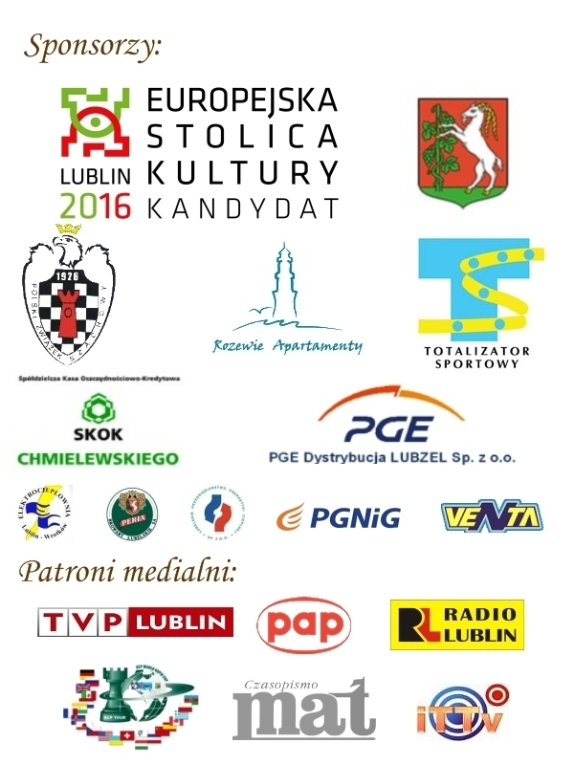

Partie rundy 4:

(1) Tiviakov,Sergei (2634) - Baklan,Vladimir (2633)
1.e4 c5 2.Sc3 d6 3.Sge2 Sc6 4.d4 cxd4 5.Sxd4 Sf6 6.Gg5 e6 7.Hd2 a6 8.0–0–0 Gd7 9.f4 Ge7 10.Sf3 b5 11.Gxf6 gxf6 12.Kb1 Hb6 13.f5 0–0–0 14.g3 Kb8 15.fxe6 fxe6 16.Gh3 Gc8 17.He1 Whe8 18.Se2 Se5 19.Wf1 Sc4 20.Sf4 Gf8 21.Hf2 Hb7 22.Sh5 Gh6 23.Wfe1 Wf8 24.Sd4 Hb6 25.b3 Sa3+ 26.Kb2 b4 27.He2 Hc5 28.Wd3 Wde8 29.Sf4 f5 30.Hd2 Gg7 31.Kc1 a5 32.exf5 exf5 33.Sde6 Gxe6 34.Wxe6 Ge5 35.Wdxd6 Wxe6 36.Sxe6 Hxd6 37.Sxf8 Hxf8 38.Hd5 Hh6+ 39.Kd1 Hd6 40.Hxd6+ Gxd6 41.Gxf5 h6 42.Kd2 Ge5 43.Ke3 Kc7 44.Kf3 Kd6 45.Kg4 Gc3 46.Kh5 Ke5 47.Gd3 Gd2 48.h4 Kd4 49.g4 Kc3 50.g5 hxg5 51.hxg5 Ge3 52.g6 Gd4 53.Kh6 Sxc2 0–1

(2) Meier,Georg (2638) - Swiercz,Dariusz (2501)
1.Sf3 Sf6 2.c4 g6 3.Sc3 c5 4.g3 Sc6 5.Gg2 d6 6.0–0 Gg7 7.d4 cxd4 8.Sxd4 Gd7 9.Sc2 0–0 10.b3 a6 11.Gb2 Ha5 12.Hd2 Wfc8 13.Wfd1 Wab8 14.Se3 b5 15.Wac1 Se5 16.Scd5 Hxd2 17.Wxd2 Sxd5 18.Sxd5 Kf8 19.f4 Sc6 20.Gxg7+ Kxg7 21.c5 Ge8 22.cxd6 exd6 23.Gh3 f5 24.e4 Gd7 25.exf5 gxf5 26.Se3 Se7 27.Wxc8 Wxc8 28.Wxd6 Wc1+ 29.Kf2 Gc8 30.Wd1 Wc5 31.Wd2 Wc1 32.Ke2 Wa1 33.Kd3 Ge6 34.Kc3 Kf6 35.Kb4 h5 36.Gg2 Kf7 37.Gf3 Kf6 38.Gxh5 Wc1 39.Gf3 1–0

(3) Dziuba,Marcin (2576) - Grachev,Boris (2667)
1.d4 d5 2.c4 c6 3.Sf3 Sf6 4.e3 e6 5.b3 b6 6.Gb2 Gb7 7.Gd3 Gd6 8.Sbd2 Sbd7 9.0–0 0–0 10.Se5 He7 11.He2 Ga3 12.Sdf3 Gxb2 13.Hxb2 Sxe5 14.Sxe5 dxc4 15.Gxc4 c5 16.dxc5 Hxc5 17.Wac1 He7 18.Gb5 Wac8 19.Gc6 Sd5 20.h3 Gxc6 21.Sxc6 Hb7 22.Se5 h6 23.Wfd1 Wxc1 24.Wxc1 Wc8 25.Wc2 Sb4 26.Wd2 Sd5 27.Wc2 Sb4 28.Wd2 Sd5 1/2

(4) Kurnosov,Igor (2680) - Bartel,Mateusz (2609)
1.e4 e5 2.Sf3 Sc6 3.Gb5 Sf6 4.d3 Gc5 5.Sbd2 0–0 6.Gxc6 dxc6 7.Sc4 We8 8.Gg5 b5 9.Scd2 h6 10.Ge3 Gxe3 11.fxe3 c5 12.b3 a5 13.a4 c6 14.He2 Ga6 15.c4 Wa7 16.0–0 Wd7 17.Se1 b4 18.Wf3 Wd6 19.Sf1 Gc8 20.h3 Sh7 21.Sg3 g6 22.Wf1 Hh4 23.Sh1 Sg5 24.Sf3 Sxf3+ 25.Hxf3 Ge6 26.Wad1 Wed8 27.Sf2 h5 28.Kh2 Kg7 29.Wd2 W6d7 30.Hd1 Hg5 31.Hf3 Wf8 32.Wdd1 Wd6 33.Kg1 Gd7 34.Kh2 Wf6 35.He2 h4 36.Sg4 Wxf1 37.Wxf1 f5 38.exf5 gxf5 39.Hf3 We8 40.Sf2 Kh6 41.g4 hxg3+ 42.Hxg3 Hxg3+ 43.Kxg3 Wg8+ 44.Kh2 Ge6 45.Sh1 Wd8 46.Wd1 Gf7 47.Kg3 Gh5 48.Wd2 Kg5 49.h4+ Kf6 50.Kf2 f4 51.exf4 exf4 52.Ke1 Ke5 53.Wg2 Gf3 54.Wg5+ Kd4 55.Sf2 We8+ 56.Kf1 Kc3 57.Se4+ Gxe4 58.dxe4 Kxb3 59.Kf2 Kxc4 60.Kf3 b3 0–1

(5) Macieja,Bartlomiej (2618) - Socko,Bartosz (2644)
1.d4 Sf6 2.c4 e6 3.Sf3 b6 4.a3 Gb7 5.Sc3 d5 6.cxd5 Sxd5 7.e3 Ge7 8.Gb5+ c6 9.Gd3 0–0 10.e4 Sxc3 11.bxc3 c5 12.0–0 Hc7 13.He2 Sd7 14.e5 Wfd8 15.Wd1 Sf8 16.Ge3 Wac8 17.Sd2 Hc6 18.Hg4 Sg6 19.Sf3 cxd4 20.cxd4 Hd5 21.h4 Sxh4 22.Sxh4 Gxh4 23.Gxh7+ Kxh7 24.Hxh4+ Kg8 25.f3 Wc2 26.Hg4 Kf8 27.a4 Wdc8 28.Hh5 Kg8 29.Hg4 Kf8 30.Hh5 Kg8 31.Hg4 1/2

