

II Międzynarodowy Arcymistrzowski Turniej Szachowy
im. Unii Lubelskiej – Lublin 8-18.05.2010

Biuletyn

Runda: 3

Nr | Tyt. | Imię i nazwisko | Fed. | Rank. | 1 | 2 | 3 | 4 | 5 | 6 | 7 | 8 | 9 | 10 | S | Mce
1 | GM | Marcin Dziuba | POL | 2576 | X | = | 1 |  |  |  |  |  |  | =
2 | GM | Sergiej Tiviakov | NED | 2634 | = | X |  |  |  |  |  |  | 0 | 1
3 | GM | Vladimir Baklan | UKR | 2633 | 0 |  | X |  |  |  |  | = | =
4 | GM | Boris Grachev | RUS | 2667 |  |  |  | X |  |  | = | = | =
5 | GM | Bartosz Soćko | POL | 2644 |  |  |  |  | X | 1 | = | =
6 | GM | Dariusz Świercz | POL | 2501 |  |  |  |  | 0 | X | 0 |  |  | =
7 | GM | Mateusz Bartel | POL | 2609 |  |  |  | = | = | 1 | X
8 | GM | Georg Meier | GER | 2638 |  |  | = | = | = |  |  | X
9 | GM | Bartłomiej Macieja | POL | 2618 |  | 1 | = | = |  |  |  |  | X
10 | GM | Igor Kurnosov | RUS | 2680 | = | 0 |  |  |  | = |  |  |  | X
www.lzszach.lublin.pl/arc2010
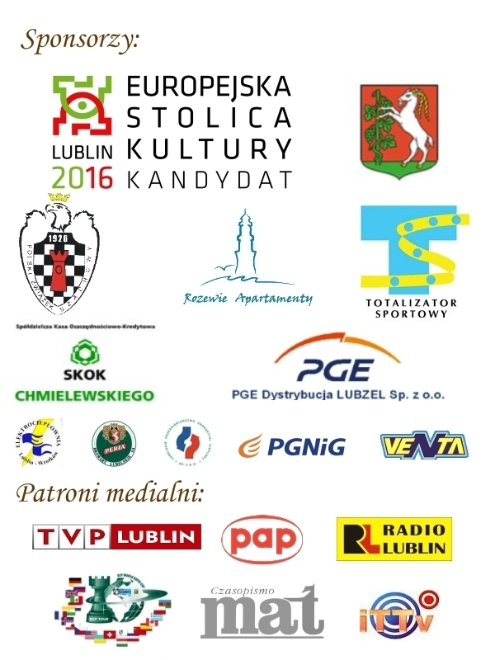

Partie rundy 3:

(1) Swiercz,Dariusz (2501) - Bartel,Mateusz (2609)
1.d4 Sf6 2.c4 e6 3.g3 d5 4.Sf3 dxc4 5.Gg2 Gd7 6.Se5 Gc6 7.Sxc6 Sxc6 8.0–0 Hd7 9.e3 0–0–0 10.Ha4 h5 11.h3 h4 12.g4 Sd5 13.Hxc4 f5 14.gxf5 exf5 15.Sc3 Sb6 16.He2 g5 17.a4 Gb4 18.Gd2 Kb8 19.Wfc1 g4 20.a5 gxh3 21.Gf3 Gxa5 22.Kh1 Gxc3 23.Wxc3 Wh6 24.Wca3 Wg6 25.b4 Wdg8 26.b5 Hd6 27.Gb4 Sxb4 28.Wxa7 h2 29.Wxb7+ Kc8 0–1

(2) Baklan,Vladimir (2633) - Dziuba,Marcin (2576)
1.e4 c5 2.Sf3 d6 3.d4 cxd4 4.Sxd4 Sf6 5.Sc3 a6 6.h3 e5 7.Sde2 h5 8.g3 Sbd7 9.a4 h4 10.g4 Sc5 11.Gg2 Ge6 12.a5 Ge7 13.b4 Scd7 14.Sd5 Gxd5 15.exd5 Wc8 16.c3 0–0 17.0–0 Sh7 18.Hd3 Hc7 19.f4 exf4 20.Gxf4 Se5 21.Hd1 g6 22.Kh1 Sc4 23.Gh6 Wfe8 24.Hd4 Gf8 25.Gxf8 Sxf8 26.Wf2 Sh7 27.Waf1 Sg5 28.Sf4 Se5 29.Wc2 Hc4 30.Hf2 Se4 31.Hxh4 g5 32.He1 Sd3 33.Sxd3 Hxd3 34.Gxe4 Wxe4 35.Hc1 We3 36.Hd1 Wxh3+ 37.Wh2 He4+ 38.Kg1 Wg3+ 0–1

(3) Socko,Bartosz (2644) - Meier,Georg (2638)
1.e4 e6 2.d4 d5 3.Sc3 dxe4 4.Sxe4 Sd7 5.Sf3 Sgf6 6.Sxf6+ Sxf6 7.c3 c5 8.Se5 a6 9.Ge3 Hc7 10.Ha4+ Sd7 11.Gb5 cxd4 12.Gxd7+ Gxd7 13.Hxd4 Gb5 14.a4 Gd6 15.Sxf7 Kxf7 16.axb5 axb5 17.Ke2 Hc6 18.Whd1 Wxa1 19.Wxa1 b4 20.Wd1 Wd8 21.Hh4 Ge7 22.Hf4+ Kg8 23.Wxd8+ Gxd8 24.Hxb4 Hxg2 25.Hb5 Hc6 26.Hxc6 bxc6 27.b4 Kf7 28.Kd3 Ge7 29.Kc4 Ke8 30.Gc5 Gf6 31.Gd4 e5 32.Ge3 e4 33.Gd4 Gh4 34.b5 Kd7 35.b6 g6 36.Kb4 Kc8 37.c4 Ge7+ 38.c5 g5 39.h3 h5 40.Kc4 g4 41.hxg4 hxg4 42.Ge5 Gh4 43.Gg3 Gf6 44.Gf4 Gh4 45.Gg3 Gf6 46.Gf4 1/2

(4) Grachev,Boris (2667) - Macieja,Bartlomiej (2618)
1.d4 Sf6 2.Sf3 g6 3.Sbd2 c5 4.dxc5 Ha5 5.a3 Hxc5 6.b4 Hc7 7.Gb2 Gg7 8.e3 0–0 9.Ge2 b6 10.0–0 Gb7 11.c4 d6 12.Wc1 Sbd7 13.Hb3 Wac8 14.Sd4 a6 15.h3 Hb8 16.Gf3 Wc7 17.Wc2 Wfc8 18.Wfc1 Se5 19.Gxb7 Hxb7 20.S4f3 Sfd7 21.Sg5 h6 22.Sge4 Sf6 23.Sxf6+ Gxf6 24.f4 Sd7 25.Gxf6 Sxf6 26.Hd3 Sd7 27.Kh2 d5 28.e4 dxc4 29.Sxc4 Sf6 30.Sd2 Wxc2 31.Wxc2 Wxc2 32.Hxc2 Hd7 33.Sf3 He6 34.e5 Sh5 35.He4 Kh7 36.a4 Sg7 37.b5 axb5 38.axb5 Hb3 39.Sd4 Hc4 40.He3 Hc5 41.He4 1/2

(5) Tiviakov,Sergei (2634) - Kurnosov,Igor (2680)
1.e4 c5 2.Sc3 d6 3.f4 Sc6 4.Sf3 g6 5.d4 cxd4 6.Sxd4 Gg7 7.Ge3 Sf6 8.Ge2 0–0 9.Sb3 b6 10.0–0 Gb7 11.Gf3 Wc8 12.Wf2 Sd7 13.Wd2 Gxc3 14.bxc3 Wc7 15.He1 Sa5 16.Sxa5 bxa5 17.Gd4 Hc8 18.Gg4 Ha8 19.e5 dxe5 20.fxe5 Sc5 21.Hh4 Se6 22.We1 Sxd4 23.cxd4 Kg7 24.c4 Hd8 25.Ge2 e6 26.Hf4 Ga6 27.d5 exd5 28.cxd5 Gxe2 29.Wexe2 Wc1+ 30.Kf2 Hb6+ 31.We3 Wfc8 32.d6 W8c2 33.Wxc2 Wxc2+ 34.Kg3 Hb2 35.d7 Wxg2+ 36.Kh3 Wf2 37.Wf3 Wxf3+ 38.Hxf3 Hd2 39.Hf6+ Kh6 40.Hh4+ 1–0

