

II Międzynarodowy Arcymistrzowski Turniej Szachowy
im. Unii Lubelskiej – Lublin 8-18.05.2010

Biuletyn

Runda: 1

Nr | Tyt. | Imię i nazwisko | Fed. | Rank. | 1 | 2 | 3 | 4 | 5 | 6 | 7 | 8 | 9 | 10 | S | Mce
1 | GM | Marcin Dziuba | POL | 2576 | X |  |  |  |  |  |  |  |  | =
2 | GM | Sergiej Tiviakov | NED | 2634 |  | X |  |  |  |  |  |  | 0
3 | GM | Vladimir Baklan | UKR | 2633 |  |  | X |  |  |  |  | =
4 | GM | Boris Grachev | RUS | 2667 |  |  |  | X |  |  | =
5 | GM | Bartosz Soćko | POL | 2644 |  |  |  |  | X | 1
6 | GM | Dariusz Świercz | POL | 2501 |  |  |  |  | 0 | X
7 | GM | Mateusz Bartel | POL | 2609 |  |  |  | = |  |  | X
8 | GM | Georg Meier | GER | 2638 |  |  | = |  |  |  |  | X
9 | GM | Bartłomiej Macieja | POL | 2618 |  | 1 |  |  |  |  |  |  | X
10 | GM | Igor Kurnosov | RUS | 2680 | = |  |  |  |  |  |  |  |  | X
www.lzszach.lublin.pl/arc2010
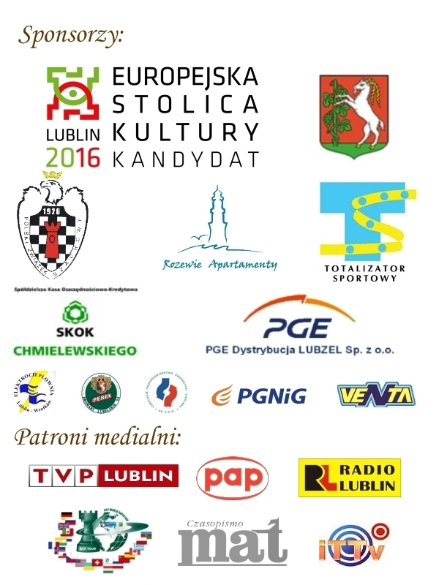

Partie rundy 1:

(1) Dziuba,Marcin (2576) - Kurnosov,Igor (2680)
1.d4 Sf6 2.c4 g6 3.g3 c5 4.d5 b5 5.cxb5 a6 6.bxa6 Gg7 7.Gg2 d6 8.Sc3 0–0 9.Sf3 Sxa6 10.Sd2 Ha5 11.0–0 Sc7 12.Sc4 Hb4 13.Se3 Sg4 14.Sc2 Hb6 15.Gd2 Sb5 16.Sxb5 Hxb5 17.h3 Se5 18.Gc3 Gd7 19.He1 Wfb8 20.b3 Gf5 21.Se3 Gc8 22.Hd2 Ga6 23.Wfe1 Sd7 24.Gxg7 Kxg7 25.Sc2 Sf6 26.e4 Hd3 27.Wed1 Hxd2 28.Wxd2 Sd7 29.f4 h5 30.h4 Gc8 31.e5 dxe5 32.d6 Wa6 33.dxe7 We6 34.f5 Wxe7 35.Se3 Sf6 36.fxg6 fxg6 37.Wd8 Wc7 38.Sc4 Wd7 39.Wxd7+ Gxd7 40.Sxe5 Ge6 41.Sc6 Wb6 42.Wc1 Wa6 43.Wc2 Sg4 44.Gf3 Gxb3 45.Wxc5 Gxa2 46.Sb4 Wa4 47.Sxa2 Wxa2 48.Gxg4 hxg4 49.Wc4 Kh6 50.Wxg4 Wa5 51.Kg2 1/2

(2) Baklan,Vladimir (2633) - Meier,Georg (2638)
1.e4 e6 2.d4 d5 3.Sc3 dxe4 4.Sxe4 Sd7 5.Sf3 Sgf6 6.Gg5 h6 7.Sxf6+ Sxf6 8.Ge3 Gd6 9.Gd3 0–0 10.He2 b6 11.0–0–0 Gb7 12.Kb1 Sd5 13.Gd2 Hf6 14.Se5 Sf4 15.Gxf4 Hxf4 16.g3 Hf6 17.Whe1 Gxe5 18.dxe5 Hf3 19.Hf1 Hg2 20.Hxg2 Gxg2 21.Ge4 Gxe4 22.Wxe4 Wad8 23.Wed4 Wxd4 24.Wxd4 f6 25.exf6 Wxf6 26.Wd2 Kf8 27.Kc1 Ke7 28.Kd1 Wf5 29.h4 a5 30.c4 a4 31.Ke2 g6 32.Wd4 c6 33.Ke3 h5 34.f3 1/2

(3) Tiviakov,Sergei (2634) - Macieja,Bartlomiej (2618)
1.e4 c6 2.d3 d5 3.Sd2 g6 4.f4 Gg7 5.Sgf3 Sh6 6.e5 d4 7.Sb3 c5 8.c3 dxc3 9.bxc3 b6 10.Ge2 0–0 11.0–0 Sc6 12.d4 cxd4 13.Sfxd4 Gb7 14.Gf3 Wc8 15.Ga3 Hc7 16.Gxc6 Gxc6 17.Sxc6 Hxc6 18.Gxe7 Wfe8 19.Gd6 Hxc3 20.Wf3 Hc4 21.Wc1 Ha4 22.Wxc8 Wxc8 23.Hd2 Sf5 24.Gb4 h5 25.g3 a5 26.Gc3 He4 27.Hd3 Hc6 28.Kg2 Gf8 29.Sd2 He6 30.a4 Ge7 31.Hb1 Hd5 32.Hd3 Ha2 33.Kh3 Wd8 34.He2 He6 35.Kg2 Sd4 36.Gxd4 Wxd4 37.Se4 Wxa4 38.Sc3 Wc4 39.Hd3 a4 40.Sd5 Wc5 41.Sxe7+ Hxe7 42.He4 Wa5 43.Hd4 He6 44.Hd8+ Kg7 45.f5 gxf5 46.Hg5+ Hg6 47.He7 Wc5 48.Wd3 Hc6+ 49.Kh3 He6 50.Hd8 f4+ 51.Kg2 Wc2+ 0–1

(4) Grachev,Boris (2667) - Bartel,Mateusz (2609)
1.d4 Sf6 2.Sf3 d5 3.c4 e6 4.g3 dxc4 5.Gg2 Gb4+ 6.Gd2 a5 7.0–0 Sc6 8.e3 0–0 9.He2 Gd6 10.Hxc4 e5 11.Sc3 exd4 12.exd4 Sb4 13.a3 Ge6 14.He2 Sbd5 15.Sg5 Gg4 16.Hb5 Sxc3 17.Gxc3 h6 18.Se4 Sxe4 19.Gxe4 Gc8 20.Wfe1 c6 21.Hc4 Gd7 22.d5 c5 23.a4 Hc7 24.We3 Wae8 25.Wae1 b6 26.Gc2 Wxe3 27.Wxe3 Hd8 28.We6 Gxe6 29.dxe6 He7 30.Hg4 fxe6 1/2

(5) Socko,Bartosz (2644) - Swiercz,Dariusz (2501)
1.e4 c5 2.Sf3 d6 3.d4 cxd4 4.Sxd4 Sf6 5.Sc3 a6 6.Ge3 e5 7.Sb3 Ge7 8.Hd2 Ge6 9.0–0–0 0–0 10.f4 b5 11.Kb1 Sbd7 12.f5 Gc4 13.Wg1 Hc7 14.g4 b4 15.Gxc4 Hxc4 16.Sd5 Sxd5 17.Hxd5 Hxd5 18.exd5 Gd8 19.Sd2 Gb6 20.Gxb6 Sxb6 21.Se4 Wfd8 22.Wg3 Wac8 23.b3 Sa8 24.Kb2 Sc7 25.c4 a5 26.Wa1 Sa6 27.a3 Sc5 28.Sxc5 bxa3+ 29.Wxa3 Wxc5 30.Kc3 f6 31.Wg1 Wa8 32.Wga1 Kf7 33.Kd3 Wb8 34.Kc2 Wa8 35.Wa4 Ke7 36.h4 h6 37.Wb4 Kd7 38.Kd3 Kc7 39.Wba4 Wb8 40.Kc3 Wa8 41.g5 hxg5 42.hxg5 fxg5 43.Wg1 Wh8 44.Wxg5 Wh3+ 45.Kc2 Wh2+ 46.Kd3 Wh3+ 47.Ke4 Wh4+ 48.Kf3 Wh3+ 49.Kg4 Wxb3 50.Wxg7+ Kb6 51.f6 Wb4 52.Wa1 Wbxc4+ 53.Kf5 Wf4+ 54.Ke6 Wc3 55.Wd7 Kb5 56.Wxd6 Wcf3 57.Ke7 e4 58.We6 Wd3 59.d6 Wf5 60.d7 Wfd5 61.Wb1+ Kc5 62.Wb7 e3 63.f7 1–0

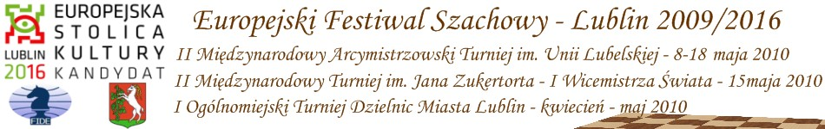

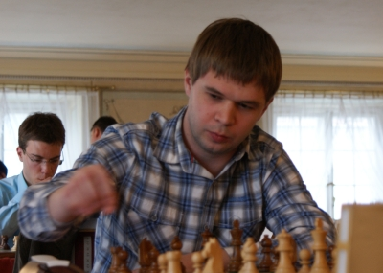  GM Igor Kurnosov  Rosja ranking: 2680 | 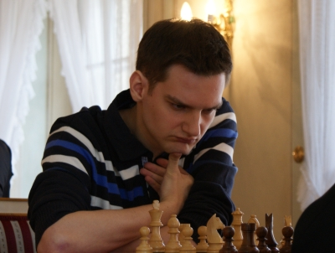  GM Boris Grachev  Rosja ranking: 2667 | 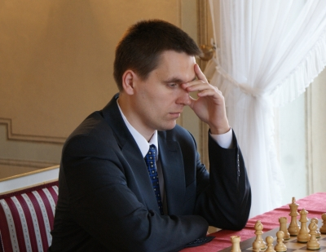  GM Bartosz Soćko  Polska ranking: 2644 | 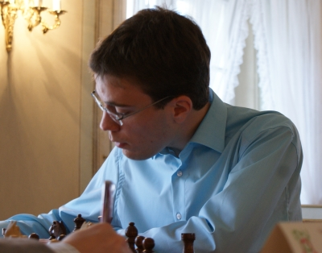  GM Georg Meier  Niemcy ranking: 2638 | 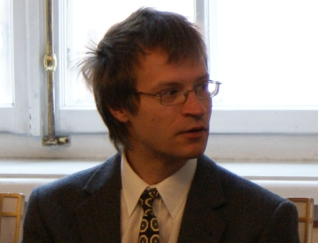  GM Sergei Tiviakov  Holandia ranking: 2634
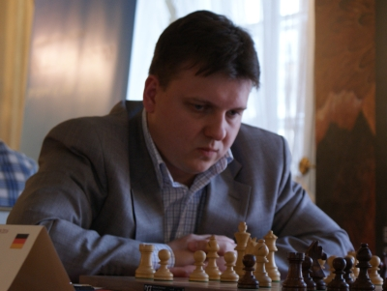  GM Vladimir Baklan  Ukraina ranking: 2633 | 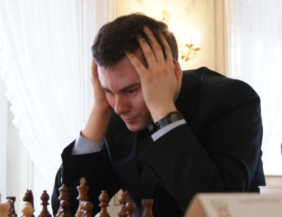  GM Bartłomiej Macieja  Polska ranking: 2618 | 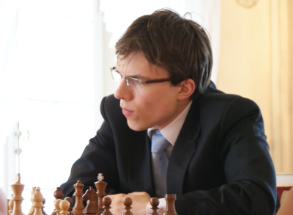  GM Mateusz Bartel  Polska ranking: 2609 | 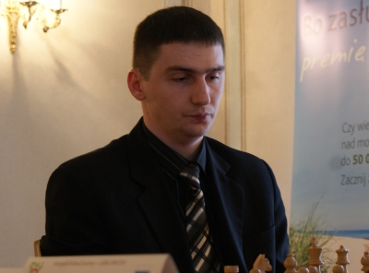  GM Marcin Dziuba  Polska ranking: 2576 | 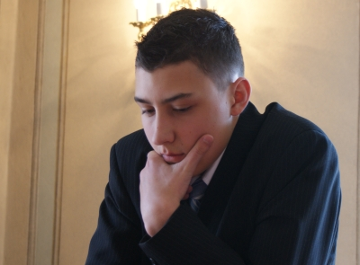  GM Dariusz Świercz  Polska ranking: 2501


